AP CARE

Support & Operation
Table of Contents

1. Modification History 3
2. Document Overview 4
3. Assumptions 4
4. Environment Overview 5
1. CARE Tier Details 5
2. GRD/Atlas & Sales Transactions Data Processing Overview Diagram 6
3. General System Information/Notes 6
5. Standard Inbound Loader (SIL) 7
6. Staging Environment 8
7. CARE Product Load 9
8. CARE Sales Load 11
9. Support/Operation Steps 11
1. Manual Product Load execution 11
2. Manual Sales Load 11
3. Add new sales company 12
4. Add new product load MOE 12

Modification History

Date | Version | Description | Reviser
22nd October, 2006 | 1.0 | Original | Linden Glen

Document Overview

This document provides both operational and support details at a technical level for the Asia Pacific installation of CARE interfaces. The intended audience is the support associates (GSM) who will take on responsibility for the installation, and any analyst/programmers intending to apply further modifications/developments.

The scope of this document covers from the arrival of a file/message onto the CARE host (WODU00x) through to the loading of data into the CARE application data table(s). It does not cover the CARE application, HUB or Atlas operations in any detail, however does make mention of these components where necessary.

Assumptions

- The reader has a basic understanding of AMI (Messaging) technologies (specifically MQFT and Data Junction).
- The reader has a basic understanding of Oracle technologies (specifically PL/SQL and SQL).
- The reader understands the functional requirements of the interfaces/data loads.

Environment Overview

CARE Tier Details

Tier | Host | Database | Data/Script Path | Intranet Site | Queue Manager
Production | WODU002 | AP0101P | /sil/care/prod/ … | www.care.ap.mars | WODU02P1
Test | WODU003 | AP0100D | /sil/care/test/ … | webappdev42.ap.mars | WODU03T1
Development

GRD/Atlas & Sales Transactions Data Processing Overview Diagram

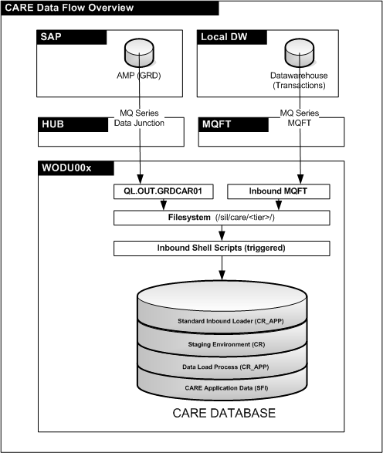

General System Information/Notes
- A large number of columns within the CARE application data schema (SFI) are of format CHAR(10). As this data type automatically pads out values, specific coding to overcome this was needed when comparing values.

Standard Inbound Loader (SIL)

The Standard Inbound Loader provides a generic infrastructure for developing and executing inbound interface file loads to the CARE staging environment. It is a real-time loader and processes files based on interface configuration. It consists of three components; shell script to handle incoming file, underlying Oracle SIL functionality and a load package specific for each interface.

- SIL Shell Script(s) Infrastructure
The SIL consists of two shell scripts, one for receiving Data Junction files from the Hub (sil_inbound_dj.sh) and the other for receiving files from MQFT (sil_inbound_mqft.sh). Both are triggered by the respective receiving technology.

Whilst each script handles the incoming connection differently, the core processing is identical. It is as follows:

- Receive incoming file to inbound directory (/sil/care/<tier>/inbound)
- Connect to Oracle and execute sil_inbound_processor, passing in the filename and interface identifier.
- Log Oracle results, cleanup and exit.

Interface Identifiers are passed to the shell scripts by the respective receiving technology. For Data Junction, this is configured at the queue level in /sil/care/<tier>/mqs_trigger_WODU02P1.config. For MQFT, this is configured by AMI and is based on the incoming filename.

These shell scripts shouldn’t need to be modified for new interfaces – they can be reused by passing in the necessary parameters at execution time.

- SIL Oracle Infrastructure
The underlying SIL infrastructure provides a generic mechanism for reading/loading files from the file system into Oracle. Each interface can choose to process the file as necessary, without having to re-develop the file reading/processing components.

The SIL Oracle Infrastructure consists of five packages, they are as follows:

Package Name | Description
SIL_NOTIFICATION | Used for sending emails (notifications/success/alerts)
SIL_PARAMETER | System configuration – stores settings for file system, critical alert addresses, system name, etc.
SIL_LOGGING | Used for creating and writing to log entries within Oracle in a standard way. Logs can be accessed from the table CR.SIL_LOG
SIL_INBOUND_UTILITY | Used to retrieve fields from the incoming file in the desired format
SIL_INBOUND_PROCESSOR | Called by the SIL Shell scripts to drive file processing/loading within Oracle

It is intended that these packages/configurations will not require further development as they are designed in a generic way and can be re-used through configuration.

- Interface Load Package
Each inbound interface requires it’s own load package. This package essentially controls what happens with each line of the receiving file (e.g. processing, logic, inserts, commits, etc.).

Each interface must have an existing entry in the table CR.SIL_INTERFACE. This will include a description, filesystem path where files are to be loaded from, email group for alerts relating to the interface and the load procedure to be called relating to this interface. The SIL_INBOUND_PROCESSOR package will use this entry to process the interface file accordingly.

At the time of writing, the following two interfaces were in place in production :

Interface ID | Description | Path | Email | Procedure
GRDCAR01 | GRD to CARE - Material | SIL_INBOUND | AP_CARE_REPORT@ap.effem.com | care_grdcar01
SALCAR01 | SALES to CARE - Historical Sales Data to AP CARE | SIL_INBOUND | AP_CARE_REPORT @ap.effem.com | care_salcar01

Staging Environment

The staging environment is used to store the raw data as it is received from the relevant source systems. This provides support groups with ability to trace what occured and allows them to confirm what was received before any further processing/logic has been applied. It also provides an area for incoming data to be stored in readiness for loading into the CARE application environment.

Data loaded into this area should be treated as a full refresh based on primary keys, with history not being stored. For example, if an Idoc is received for an existing material code, the data in the staging area for that material would be deleted and reloaded completely from the Idoc.

Where possible, timestamp checks should be applied to incoming interfaces. E.g. don’t overwrite existing data in the staging area if it has a newer creation timestamp than one being received. In the case of Idocs this information is in the CTL record.

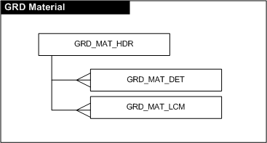
The following two staged data sets exist in the CR schema :

This data is used for the CARE Product load interface.
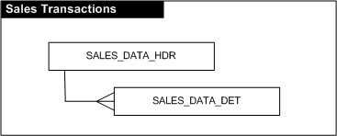
This data is used for the CARE Sales load interface.

CARE Product Load

The CARE product load handles the processing of GRD material data from the staging environment to the SFI.KEYWRD table for use by the CARE application.

The GRD materials are sent from SAP at the Traded Unit (TDU) level, however, CARE requires them at the Representative Sales Unit (RSU) level. The following logic flow outlines how this load procedure (CARE_DATA_LOAD) processes materials through to the SFI.KEYWRD table.
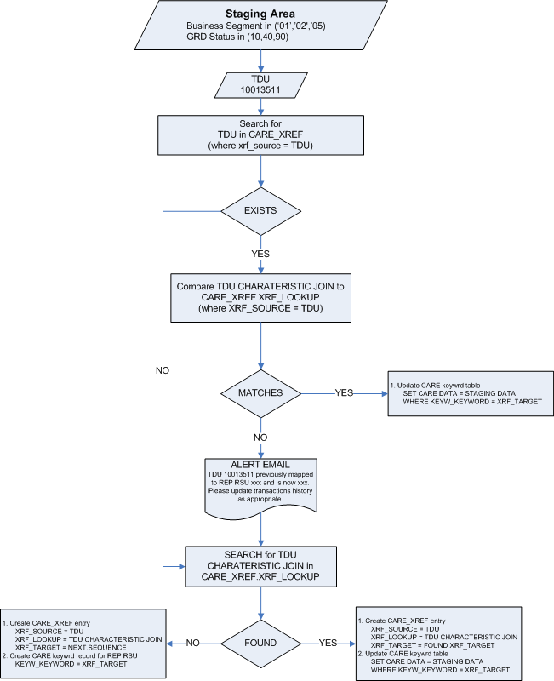

The following points should also be noted in regards to this package :

- GRD TDU’s are grouped to a pseudo RSU by combining the codes of their characteristics. E.g. brand code + sub-brand code + ingredient variety code, etc. When a match is found, it is assumed that these GRD TDU’s link to the same RSU. This cross-reference is stored in the CR.CARE_XREF table. It includes the GRD TDU, Characteristic Joined code, pseudo RSU and status.
- A GRD TDU can potentially change it’s charateristics (ie. If someone updates it in SAP). Therefore, the CARE_XREF table maintains a status, where the last loaded material characteristic is Active, but any prior ones are Inactive. This allows for historical traceability as transactions within CARE could have been made between updates.
- The package will only allow the loading of TDU’s that have a SELL MOE defined in the view CARE_TDU_VW.

CARE Sales Load

The CARE sales load handles the processing of sales transactions data from the staging environment to the SFI.KEYPRD table. The data is by GRD material by SELL MOE by period. The processing logic for this load is straight forward, simply taking the GRD materials, identifying a corresponding RSU (via CARE_XREF) and loading sales data against the relevant period column.

There are four validation checks that the sales data must pass prior to it being loaded into the SFI.KEYPRD table.

- The SELL MOE (source code) and Mars period specified is valid.
- The header count matches the actual detail line count.
- The region type code is defined.
- Material codes have a a) valid legacy cross reference in GRD_MAT_LCM and b) REP RSU cross reference in CARE_XREF.

Support/Operation Steps

Manual Product Load execution

    - Connect to database as CR_APP
    - Care product load package accepts one parameter, which can be :
‘*ALL’ - to load all currently defined MOE products, or a specific MOE code (e.g. ‘0168’).
    - To execute the package, run as follows (where par_action is the type of load you wish to perform:
EXECUTE CR_APP.CARE_DATA_LOAD.EXECUTE ( PAR_ACTION );
Note: the ‘*ALL’ option is recommended only for nightly batch processing. Processing all MOE code materials may take an extended amount of time.
    - A load report will be emailed to the group defined in SIL_PARAMETER.EMAIL_DATA_LOAD

Manual Sales Load

    - Connect to database as CR_APP
    - The sales data must exist in the staging environment (CR.SALES_DATA_HDR)
    - Care Sales load accepts 2 parameters. One is the Source MOE code and the other is the Mars Period
    - To execute the package, run as follows :
EXECUTE CR_APP.CARE_SALES_LOAD.EXECUTE (PAR_SRC_CODE,PAR_YYYYPP);
    - A load report will be emailed to the group defined in SIL_PARAMETER.EMAIL_SALES_LOAD

Add new sales company

    - Connect to database as CR_APP
    - Two inserts into the CODE_LOOKUP table are now required.
    - The first one will define the SELL MOE source description :
Insert into code_lookup(XRF_TYPE, XRF_SRC, XRF_TRG)
Values ('SRC_CODE', '0086', 'NEWZEALAND');
commit;
    - The second one will define the GRD region code that is to be used for material conversions:
Insert into code_lookup(XRF_TYPE, XRF_SRC, XRF_TRG)
Values (' REG_CODE', '0086', '10');
commit;

Add new product load MOE

    - Retrieve the source code for the view CR_APP.CARE_TDU_VW
    - In the “where” clause of the query is a statement similar to :
and b.orgentity in ('0042','0196','0168',……
    - Include the new MOE code into this list.
    - Connect to database as CR_APP and re-compile view.
    - You can now execute the product load as usual.

